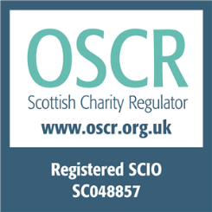

Scottish Charity No: SC048857

Bank of Scotland
Moldova Support Group
Sort code: 80 22 60

Account number: 14865364

